Name: Class:
Introduction
The following naming conventions are used for organic compounds.
- Identify the longest continuous carbon chain that includes the most important functional group. In alkenes, the most important functional group will be the carbon–carbon double bond; in alcohols it will be the hydroxy (–OH) group.
- Number the main chain carbons so that the major functional group is on the carbon with the lowest possible number. If the molecule is an alkane, number the main chain so that the side groups have the lowest numbers possible.
- Alkyl branches are named as methyl (–CH₃), ethyl (–CH₂CH₃) etc.
- Other functional groups are amino (–NH₂), fluoro (–F), chloro (–Cl), bromo (–Br) and iodo (–I). Compounds containing the COOH functional group are named as carboxylic acids.
- Numbers are used to indicate the positions of branches and functional groups.
- Commas are used to separate numbers from each other. Hyphens are used to separate numbers and words.

No. | Question | Answer
Name the molecules whose structures are shown below.

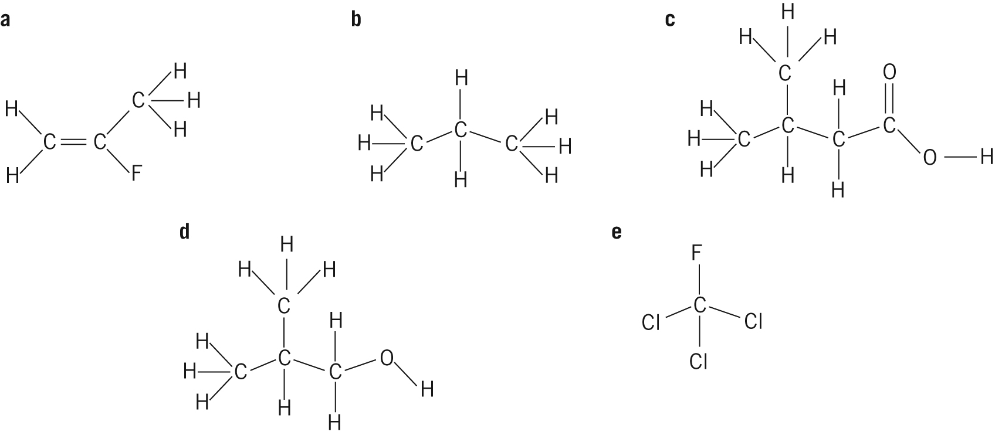

Draw structural formulas for:
a chloroethene
b 2-fluoropropan-1-ol
c 3-methylpentan-3-amine
d 2-methylbutan-2-ol.

Excluding cyclic compounds, what is the general formula for the homologous series of:
a alkanes?
b alkenes (1 double bond only)?
c alcohols?
d carboxylic acids?
a Draw and name the isomers of C₄H₁₀.
b Predict which of the isomers would have the higher boiling point. Explain your reasoning.

Excluding cyclic compounds, draw and name all the isomers of C₅H₁₀.
(Hint: Remember to include the geometric isomers (cis and trans).)

 | Draw and name the isomers of C₄H₉Cl.

